**Decision tree for train dataset**

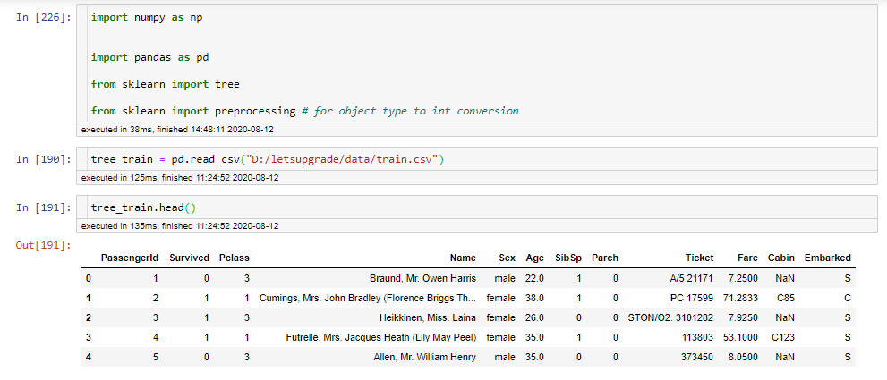

Import required model & data set for decision tree

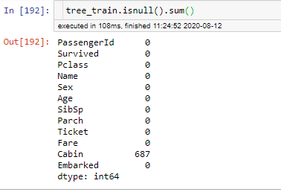

Check null value present in data set or not

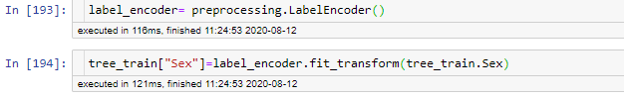convert String data into numerical value

Model 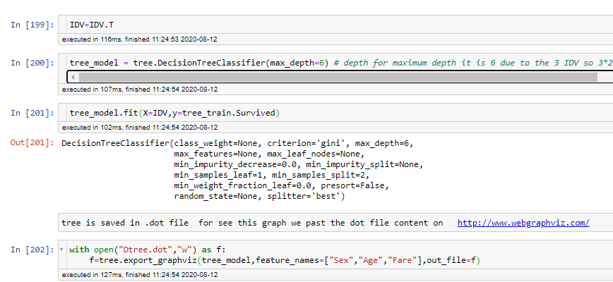formed & save the decision tree in .dot file fix the decision tree height is max 6 due to 3 variable & binary split so 3*2 = 6

**Female side Decision tree**

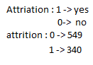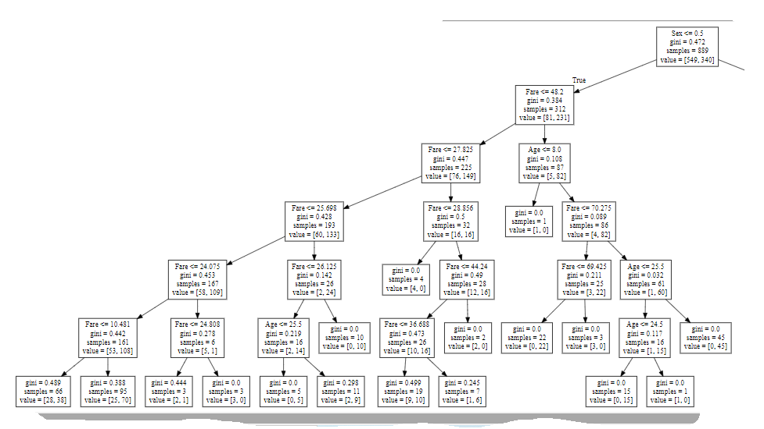

Rule formed by decision tree is

1. Sex =Female & fare <=25.698 & fare>=24.808 🡪unservived
2. Sex =Female & fare <=26.125 & age <=25.5🡪 survived
3. 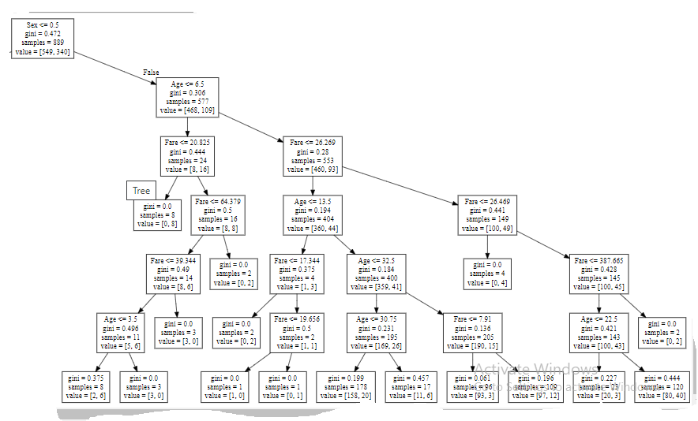Sex= Female & fare <=48.2 & fare >=26.125🡪survived
4. Sex= Female & 27.825 <= fare <= 28.856 🡪unservived
5. ……………………………………………………….

**Sex=Male side decision Tree**

1. Sex =male & fare<20.825 & age<6.5 🡪survived
2. Sex= male & age<=6.5 & 39.344<fare<=64.379 🡪unsurvived
3. Sex= male & 3.5<= age <=6.5 & 39.344<fare<=64.379 🡪unsurvived
4. Sex= Male & age<=6.5 fare>64.379 🡪survived
5. ………
6. ……………….